CHAPTER 3
METHODOLOGY

Activity Flowchart
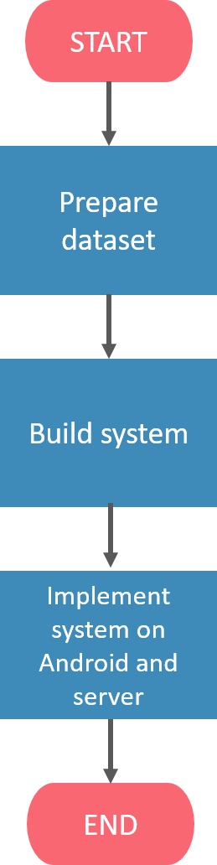
Figure 3.1 General Flowchart for Personality Prediction Application.

Figure 3.1 shows the general flowchart of the main tasks needed to build the personality prediction application. The first task was to prepare the dataset by extracting Twitter data via the Twitter API and having psychology experts annotate the data. The personality prediction system was then built by training it with the prepared dataset. Finally, the trained system was implemented onto a server with an Android device as its client.

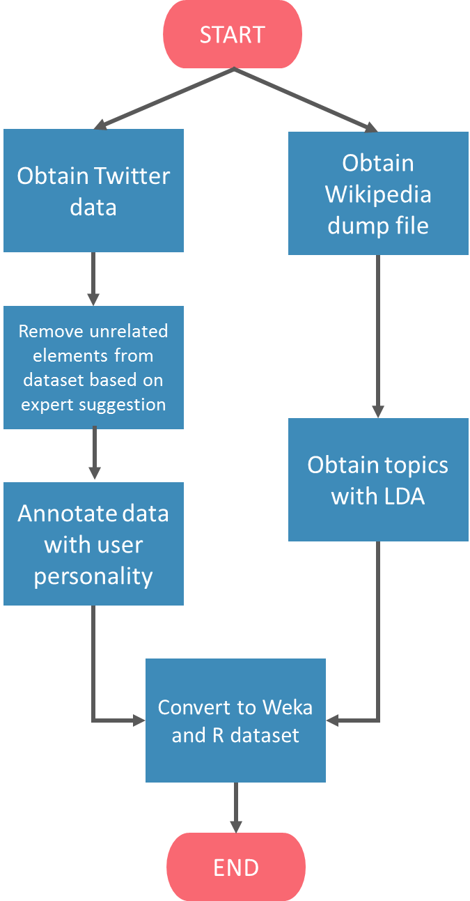
Figure 3.2 Flowchart for Data Collection.

Figure 3.2 shows the flowchart of the taken steps to prepare the dataset. The program first obtains Twitter data via the Twitter API. The initial information to be extracted from the dataset were chosen based on literatures on personality prediction, which is further discussed among psychology experts. Unrelated elements identified during the discussion were omitted from the dataset. Once the dataset was prepared, it was distributed to psychology experts for annotation. After receiving the annotated datasets, the data was converted into dataset with formats supported by Weka and R.

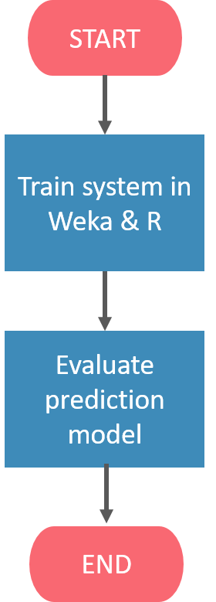
Figure 3.3 Flowchart for Building Prediction System.

Figure 3.3 shows the flowchart for building the personality prediction model. The prediction system was built with the Support Vector Machine algorithm and Gradient Boosting Tree algorithm. Loading the training dataset is required to build a trained prediction model. Finally, an evaluation was done to test the prediction system’s performance in performing personality prediction.

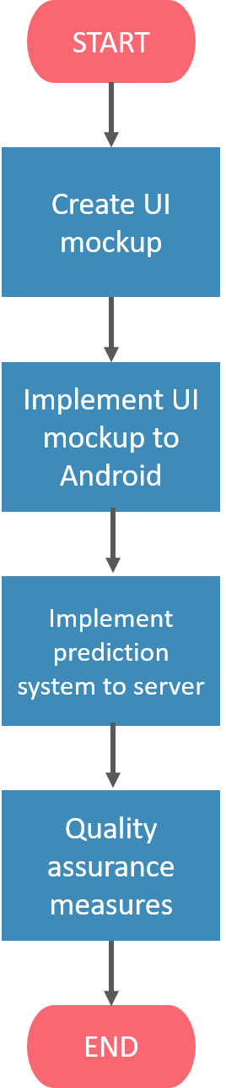
Figure 3.4 Flowchart of System Implementation to Application.

Figure 3.4 shows the flowchart consisting of the steps taken to implement the prediction system into a working application. Firstly, the mockup of the application UI was created, which was then implemented to Android. Afterwards, the prediction system was implemented into a server. In this case, the Android device acts as a client requesting the prediction results from the server.
In addition, quality assurance measures were done to check that the application and server are functioning properly.

Prepare Dataset
The prepared dataset consists of a set of tweets from Twitter users. Users are chosen based on several criteria, namely:
- User is an active Twitter user.
The user posts on Twitter at least once a month until said user’s last posted tweet date.
- User uses Bahasa Indonesia as their main language.
Each tweet is checked for its Bahasa Indonesia usage. A user is considered to tweet in Bahasa Indonesia as their main language if tweets in Bahasa Indonesia exceed tweets which are non-Bahasa Indonesia.
For cases where a tweet contains Bahasa Indonesia and non-Bahasa Indonesia language, the tweet is considered as a Bahasa Indonesia tweet, if it fulfills the following condition:
- The context of the tweet is written in Bahasa Indonesia
- Bahasa Indonesia terms exceed non-Bahasa Indonesia terms.
The dataset was divided into two – the train dataset and the test dataset.
- Train dataset
This dataset was used as training data to build the personality prediction model. A set of Twitter users’ information were obtained using the Twitter API to create the dataset. These datasets were annotated with labels of each personality trait, where each label describes whether the user has a high or low level of a certain personality trait. The personality traits used are based on McCrae and Costa’s Five Factor Model, consisting of Openness, Conscientiousness, Extraversion, Agreeableness, and Emotional Stability. Annotation was done by psychology experts. Labeled data was then used as raw training data for the personality prediction system.
- Test dataset
The test dataset was obtained the same way as the train dataset: extracting Twitter information from various Twitter users via the Twitter API. Test dataset was also annotated with 5 personality labels by psychology experts.
The test dataset was only used for testing/evaluation purposes, and not used to train the personality prediction system.

Obtain Twitter Data
Data collection was done by creating a program to retrieve user information and tweets from each listed user using functions provided by the Twitter API.

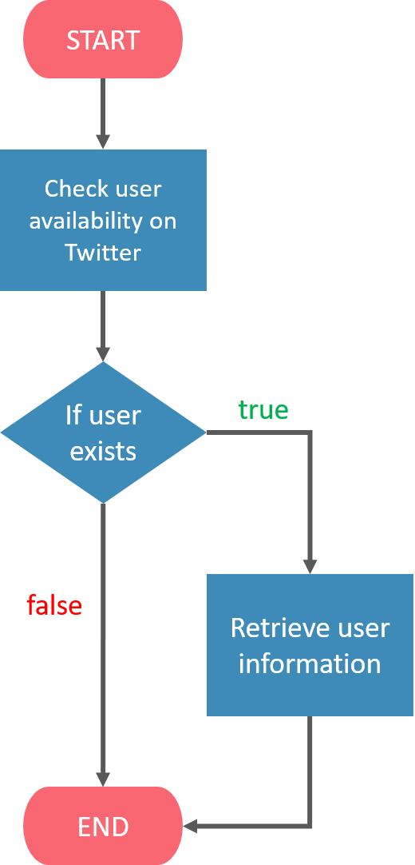
Figure 3.5 Flowchart for Checking Twitter User Availability

Upon reading a username, the program connects to Twitter via the API, and checks whether the listed user is available. If the user is available on Twitter, the API will return a set of information regarding the user. Otherwise, the API will return an exception to notify the program that the user isn’t available.

Basic Twitter User Information
The first extraction involves obtaining basic Twitter user information from Twitter. The extracted information acts as the few of the selected social behavior feature.
The following are the basic information extracted from Twitter.
- User tweet count
The total number of tweets posted by the user from account creation up until extraction date and time.

- User followers count
The total number of Twitter accounts following the user from account creation up until extraction date and time.
- User following count
The total number of Twitter accounts followed by the user from account creation up until extraction date and time.
- User favorites count
The total number of times a user favorited / liked a certain tweet.

User Tweets
Besides the previously mentioned information, a total of 200 tweets or less were extracted from the user. Each tweet is categorized into a certain tweet type. This study categorizes tweets into 5 types of tweets: normal tweet, retweets, quote tweet, mention tweet, and reply tweet.

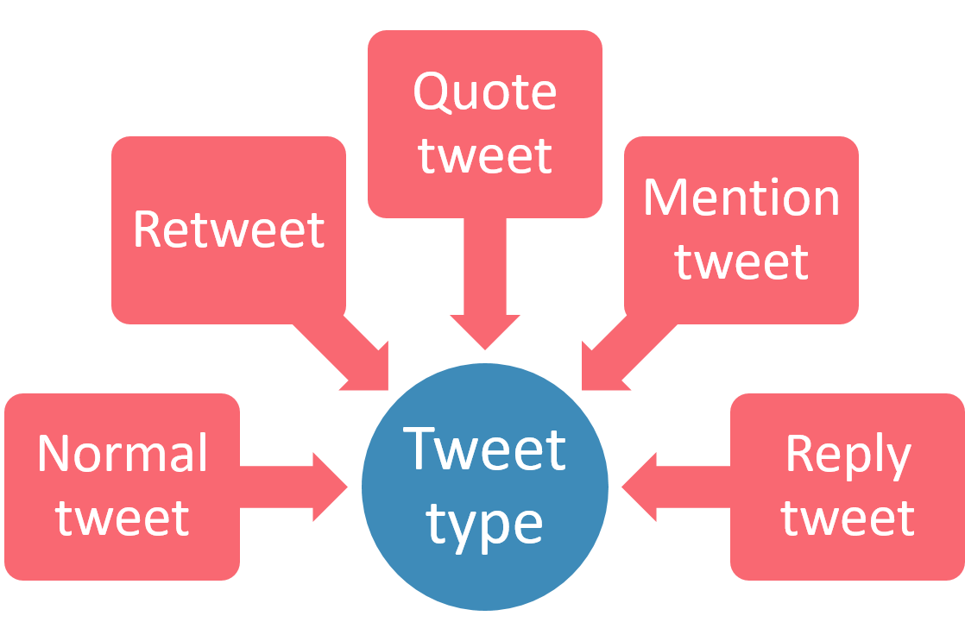
Figure 3.6 Types of User Tweets Used in Current Study

- Normal tweet
Normal tweet is a type of tweet in which the user merely posts a status without using any other Twitter features (retweet, quote, mention, reply, favorite, etc.)

- Retweet
Retweet is a type of tweet where the user reposts something which has been posted by other Twitter users using Twitter’s retweet feature.
- Quote tweet
Quote is a type of tweet where the user reposts something which has been posted by other Twitter users and adding his/her own post in regards to the reposted tweet. Quoting is also part of Twitter’s feature.
- Mention tweet
Mention is a type of tweet where the user calls out other Twitter users using the “@username” string without referencing any previous tweets. Mention is part of Twitter’s feature.
- Reply tweet
Reply is a type of tweet where the user calls out other Twitter users using the “@username” string and referencing a certain existing tweet. Though it shares a similar form with mention tweet, it is a different Twitter feature used to reply (reference) to a certain tweet.
The extracted tweets were then scanned for additional features which help determine the social behavior of the user. The selected features are as follows.
- User retweets count
The total number of times the user retweeted a certain tweet among the extracted tweets.
- User retweeted count
The total number of times the user’s tweet(s) has been retweeted by other users amongst the extracted tweets.
- User quote count
The total number of times the user posts a quote tweet.
- User mentions count
The total number of times the user utilized the mention feature amongst the extracted tweets.

- User replies count
The total number of times the user utilized the reply feature amongst the extracted tweets.
- User hashtag count
The total number of times the user utilized the hashtag feature amongst the extracted tweets.
- User URL count
The total number of times the user posted a link on his/her tweet amongst the extracted tweets.
- User Date-Time average
The average time difference between each of the tweets which were extracted. The time difference for each tweet is calculated and averaged.

Remove Unrelated Element

Automatic Element Removal
After retrieval of user information, a few preprocessing functions were applied, which are as follows.
- Omitting and counting retweets
A retweet’s content doesn’t reflect the personality of the user as it is merely a repost of another user’s tweet. Therefore, all extracted tweets which are of type retweet are omitted from the tweets list.
On the other hand, the retweet action itself might reflect the personality of the user as it shows social behavior. For this reason, all retweets from the set of extracted tweets are counted.
Omission of retweets is also adapted in Wijaya et al. (2016)’s study.
- Replace mention with token
Mentions come in form of “@username” string, where the first character is an “@”, followed by a 15 characters or less alphanumeric or underscore characters. The string that comes after “@” represents the identity of each user on Twitter. Since it is merely an identity of a user, mentions are replaced with the “[UNAME]” token. This also applies to tweets of type reply. Figure 3.7 shows the example of original tweet that contain mention inside. Example of tweet that has mention and being replaced with token after the preprocessing functions were applied is shown in Figure 3.8.

Tiap stalk akun @perfectbabies selalu ngabarin pacarnya dan bilang "yang, mau yg kayak gini" Yaelah tsay, kurang kurangin halu nya.

Tiap stalk akun @perfectbabies selalu ngabarin pacarnya dan bilang "yang, mau yg kayak gini" Yaelah tsay, kurang kurangin halu nya.

Figure 3.7 Example of Tweet Before Replacing Mention with Token

Tiap stalk akun [UNAME] selalu ngabarin pacarnya dan bilang "yang, mau yg kayak gini" Yaelah tsay, kurang kurangin halu nya.

Tiap stalk akun [UNAME] selalu ngabarin pacarnya dan bilang "yang, mau yg kayak gini" Yaelah tsay, kurang kurangin halu nya.

Figure 3.8 Example of Tweet After Replacing Mention with Token

- Replace hashtag with token
A hashtag is a Twitter feature which allows people to easily follow topics they are interested in. It comes in form of “#topic” string, where “topic” can be any character except spaces and punctuation. Figure 3.9 shows the example of tweet containing hashtag. Since the current study doesn’t take semantic features of hashtags into account, hashtags are changed into the “[HASHTAG]” token. The example of tweet containing hashtag that was replaced with token is shown in Figure 3.10.

ikut2an biar kekinian dan diretouch lg pake linecamera supaya ada efek2 rainbow #pitu #wish… https://t.co/ZztNZq0b3o

ikut2an biar kekinian dan diretouch lg pake linecamera supaya ada efek2 rainbow #pitu #wish… https://t.co/ZztNZq0b3o
Figure 3.9 Example of Tweet Before Replacing Hashtag with Token

ikut2an biar kekinian dan diretouch lg pake linecamera supaya ada efek2 rainbow [HASHTAG] [HASHTAG]… https://t.co/ZztNZq0b3o

ikut2an biar kekinian dan diretouch lg pake linecamera supaya ada efek2 rainbow [HASHTAG] [HASHTAG]… https://t.co/ZztNZq0b3o
Figure 3.10 Example of Tweet After Replacing Hashtag with Token

- Remove hyperlink
Hyperlink in twitter could be a link or a reference to another website, video link, or image. Twitter API could retrieve and translate the hyperlink. Hyperlink needs to be removed because it can’t describe personality of the user.
All kinds of links posted in Twitter are converted into the “https://t.co/code” format, where “code” consists of 10 randomly generated alphanumeric characters assigned by Twitter. One example of tweet that contains hyperlink is shown in Figure 3.11. Since the format does not vary in any way, links aren’t able to describe the personality of the user. Therefore, links are omitted from the tweet. Figure 3.12 shows the example of tweet containing hyperlink that was removed.

ikut2an biar kekinian dan diretouch lg pake linecamera supaya ada efek2 rainbow [HASHTAG] [HASHTAG]… https://t.co/ZztNZq0b3o

ikut2an biar kekinian dan diretouch lg pake linecamera supaya ada efek2 rainbow [HASHTAG] [HASHTAG]… https://t.co/ZztNZq0b3o
Figure 3.11 Example of Tweet Before Removing Hyperlink

ikut2an biar kekinian dan diretouch lg pake linecamera supaya ada efek2 rainbow [HASHTAG] [HASHTAG]…

ikut2an biar kekinian dan diretouch lg pake linecamera supaya ada efek2 rainbow [HASHTAG] [HASHTAG]…
Figure 3.12 Example of Tweet After Removing Hyperlink

Removal of hyperlinks are also adapted in Wijaya et al. (2016)’s study.

- Remove emoji
Emoji is a small digital image or icon, ideogram and smiley used to express an idea. Twitter allows insertion of emoji(s) in tweets. But since the program cannot take emojis as input, emojis are also removed from the tweet. Figure 3.13 shows an example of tweet contains emoji and Figure 3.14 shows an example of tweet that the emoji inside already removed.
Tiap stalk akun [UNAME] selalu ngabarin pacarnya dan bilang "yang, mau yg kayak gini" Yaelah tsay, kurang kurangin halu nya.

Tiap stalk akun [UNAME] selalu ngabarin pacarnya dan bilang "yang, mau yg kayak gini" Yaelah tsay, kurang kurangin halu nya.

Figure 3.13 Example of Tweet Before Removing Emoji

Tiap stalk akun [UNAME] selalu ngabarin pacarnya dan bilang "yang, mau yg kayak gini" Yaelah tsay, kurang kurangin halu nya.

Tiap stalk akun [UNAME] selalu ngabarin pacarnya dan bilang "yang, mau yg kayak gini" Yaelah tsay, kurang kurangin halu nya.

Figure 3.14 Example of Tweet After Removing Emoji

Removal of emojis are also adapted in Wijaya et al. (2016)’s study.

Manual Element Removal
Besides applying automatic preprocessing techniques, the dataset was also cleaned manually for unwanted data. The following are data that are removed from the list of tweets.
- Tweets with non-Bahasa Indonesia tweets
Tweets are considered non-Bahasa Indonesia if the non-Bahasa Indonesia terms exceed Bahasa Indonesia terms. Non-Bahasa Indonesia terms also include terms from Indonesia’s local dialect (e.g. Javanese and Sundanese). These tweets are removed from the list of tweets for each user.
Non-Bahasa Indonesia tweets are removed in accordance with this study’s scope. The study focuses on building a personality prediction system for Bahasa Indonesia language.
- Empty tweets
Occurrences of empty tweets are caused by the remove emoji and remove hyperlink function during automatic preprocessing. There are instances where the original tweets only contain emoji(s) or hyperlink(s). In such cases, the remove emoji and remove hyperlink function will completely remove the contents of the tweets, leaving the tweets empty. Such instances are removed from the list of tweets. Empty tweets are removed from the list since no features can be extracted from an empty tweet.
- Tweets with only one [UNAME] or only one [HASHTAG]
Tweets where its contents only consist of one [UNAME] or one [HASHTAG] token are removed from the list of tweets as it doesn’t represent much significance other than the token itself. These tokens are also already represented in the features mentioned above, where [UNAME] is represented by the mention count and reply count, whereas the [HASHTAG] is represented by the hashtag count feature.
Tweets with only one [UNAME] or only one [HASHTAG] are removed based on the discussion with psychology experts. They mentioned that tweets with only “[UNAME]” and “[HASHTAG]” don’t express much about user’s personality.
- Tweets with elements from other social media
Twitter allows the integration of other social medias which enables users to post tweets from other social medias. Posts from other social medias often contain tokens that signify that the post is not from Twitter.
Instances of such tweets are not fully removed, but only the tokens generated from other social media. These tokens are omitted because they aren’t written by the user and therefore doesn’t represent the user’s personality.
An example of a tweet originating from a social media named Path is presented in Figure 3.15.

Syukuran 50eps[HASHTAG] (with Angela, rickyzaldi, and 8 others at Jalan Sepat) [pic]

Syukuran 50eps[HASHTAG] (with Angela, rickyzaldi, and 8 others at Jalan Sepat) [pic]

Figure 3.15 Example of Tweet Originating from Path

Removal of elements from other social media are based on the discussion with psychology experts. They mentioned that these elements are automatically generated content from other social media, and thus doesn’t reflect the user’s personality.
- Remove excessive tweets
A discussion with psychology experts suggested that in order to annotate faster, the number of tweets should be set to a maximum of 100 per user. Therefore, excessive tweets more than a 100 are removed from the set of tweets.
- Remove users with less than 20 tweets
After executing all preprocessing methods mentioned above, the remaining tweets will be counted. Users with total number of remaining tweets less than 20 are removed from the dataset as not much information can be gained from the tweets feature.
Removal of users with less than 20 tweets are based on the discussion with psychology experts. They said that it would be difficult to annotate users with less than 20 tweets as there is not much user content to assess their personality.

Data Annotation by Expert
The output of Section 3.2 is an Excel file which has been preprocessed. This file was edited again to add radio buttons and navigation buttons to ease the annotation process by psychology experts. To ensure annotation correctness and consistency, the file also includes annotation instructions and high-low metrics for each personality trait based on the Handbook of Personality Assessment by Weiner and Greene (Weiner & Greene, 2008, p. 327-334).
The format of the file is presented below.

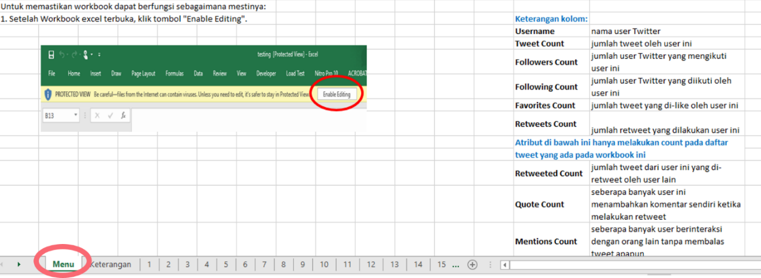
Figure 3.16 Excel File Instructions.

Figure 3.16 shows the content of the first worksheet. Annotation instructions are included in this worksheet.

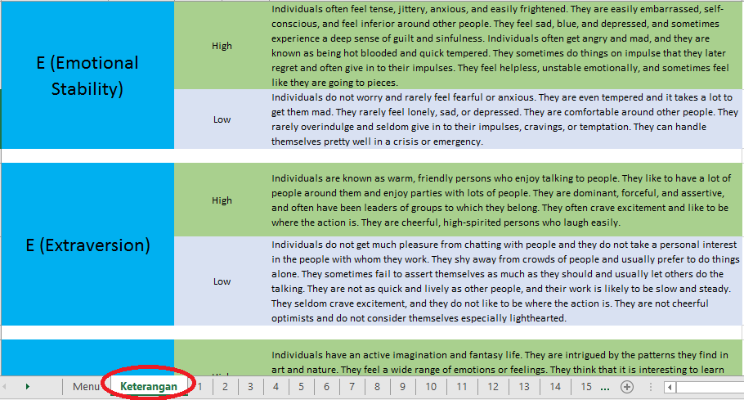
Figure 3.17 Excel File High-Low Metrics.

Figure 3.17 shows the content of the second worksheet. This worksheet consists of the high-low metrics for each personality trait.

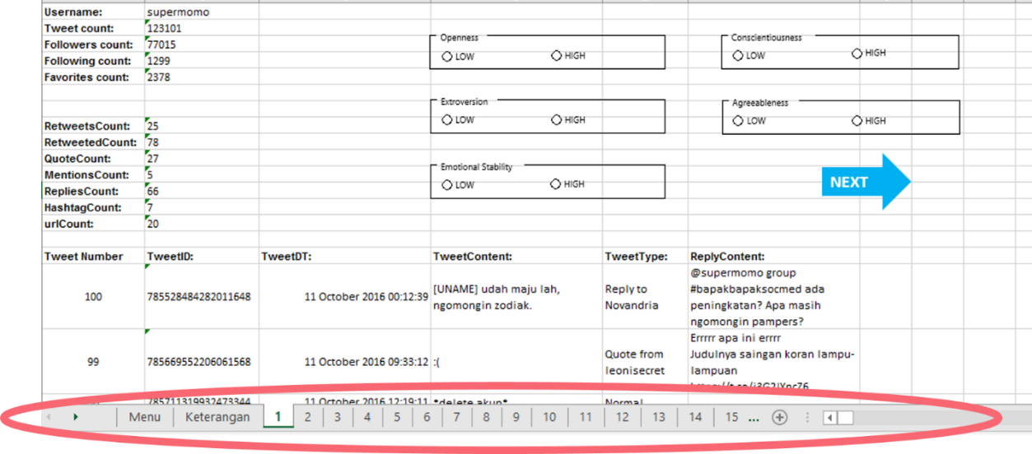
Figure 3.18 Excel File User Information - Worksheets

Figure 3.18 shows the third and following worksheets. These worksheets contain the user information extracted from Twitter. Each user is represented by each worksheet.

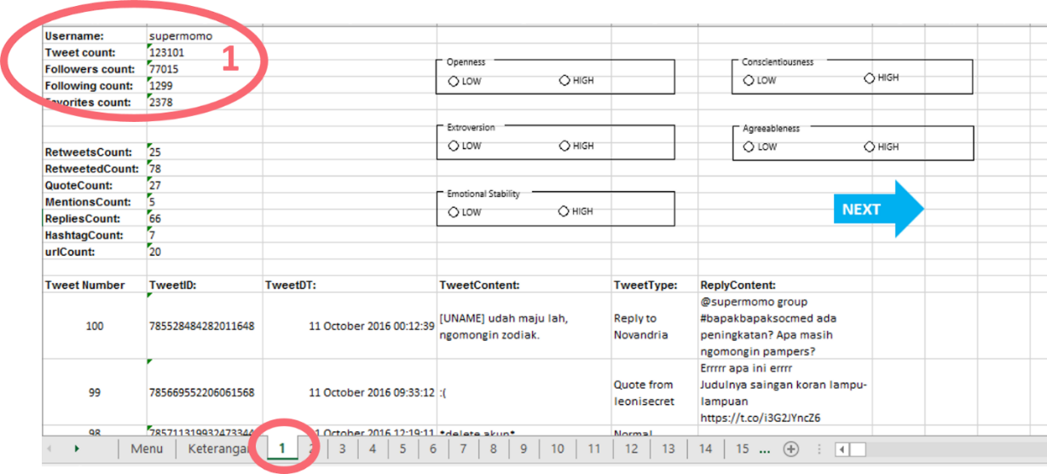
Figure 3.19 Excel File User Information – Twitter Information

Figure 3.19 shows one of the contents from the user information worksheet. The portion marked by circle 1 contains the user’s Twitter information.

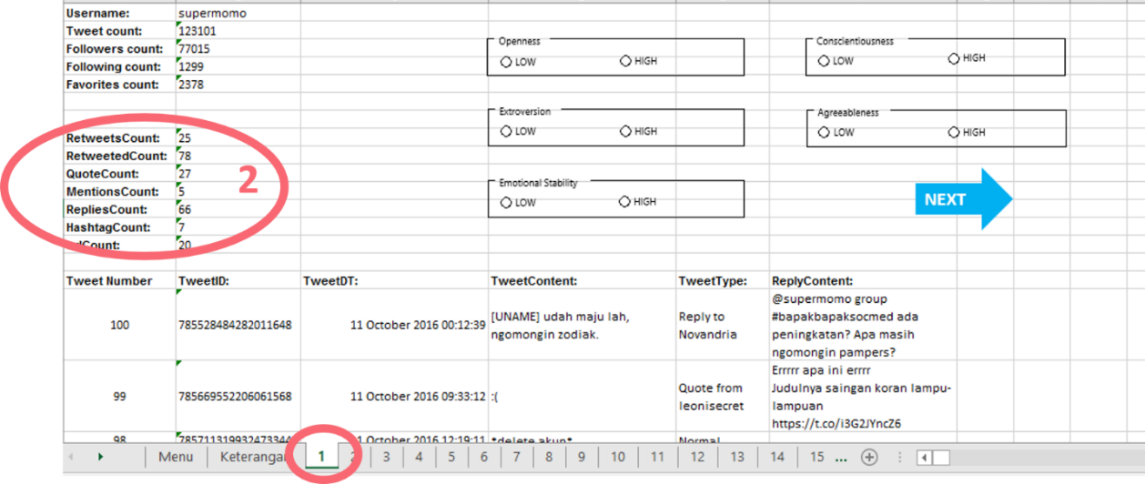
Figure 3.20 Excel File User Information – Count Features

Figure 3.20 shows the second content from the user information worksheet. The portion marked by circle 2 contains the count features for each user.

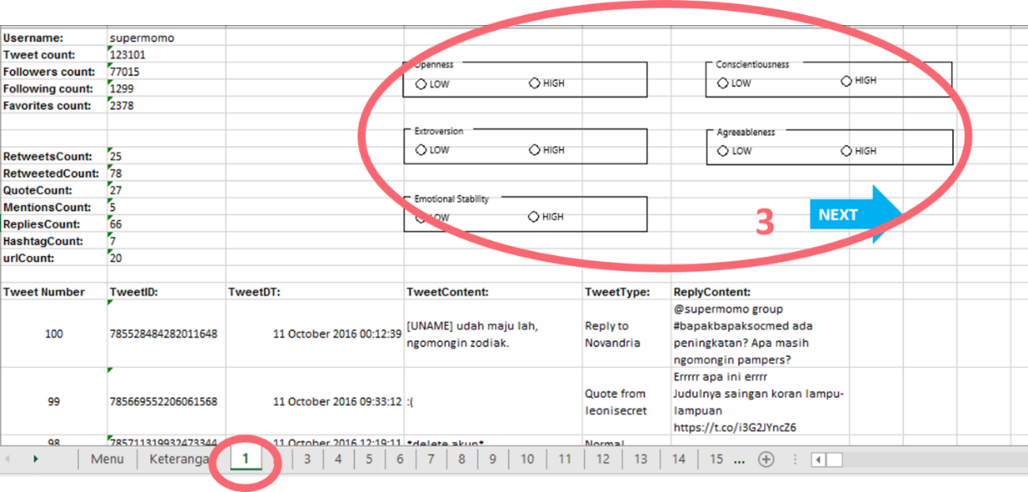
Figure 3.21 Excel File User Information – Radio Buttons

Figure 3.21 shows the third content from the user information worksheet. The portion marked by circle 3 contains the radio buttons for each personality. A radio button was provided for each personality. These radio buttons were provided for annotation means by psychology experts.

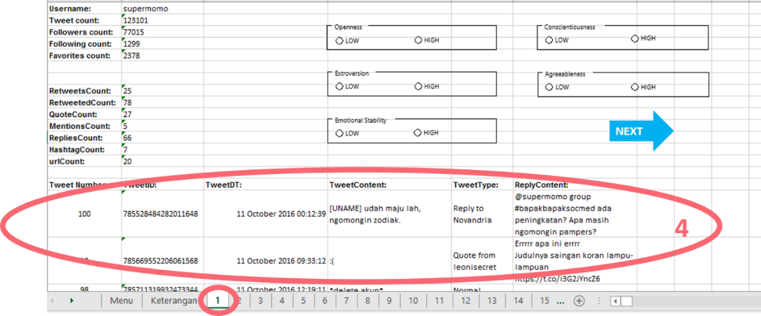
Figure 3.22 Excel File User Information – User Tweets

Figure 3.22 shows the fourth content from the user information worksheet. The portion marked by circle 4 contains a list of tweets from each user. Tweet count, tweet ID, tweet date and time, tweet content, tweet type, and the content for the tweet that is referenced (only for reply and quote tweets) are provided for each tweet.
This edited Excel file was then distributed to psychology experts which have agreed to aid in the annotation process. Annotation was done through expert judgement means, and therefore require experts on the area of The Five Factor Model. This study defined several criteria to ensure that annotation is handled by experts. The criteria are as follows.
- Expert must have at least a Master’s degree in Psychology.
- Expert must be familiar with The Five Factor Model.
The following shows the list of psychology experts who agreed to help in the annotation process.
1. Mrs. Esther Widhi Andangsari, M.Psi., Psi., a psychology lecturer in Bina Nusantara University
2. Mr. Aryo E. Nugroho, S.Psi., M.Sc., a psychology lecturer in Bina Nusantara University
3. Mr. Muhamad Nanang Suprayogi, S.Psi., M.Si., a psychology lecturer in Bina Nusantara University
4. Mr. Tri Swasono Hadi, M.Psi., Psi., a practitioner in clinical psychology

Obtain Wikipedia Dump File
A large corpus is needed to load into the Latent Dirichlet Allocation algorithm. One of the largest corpus that can be obtained and is available to public is the Wikipedia dump file. A Wikipedia dump file contains the content of every article available on Wikipedia. For this reason, the latest dump file for the Indonesian version of Wikipedia (as of December 6 2016) was obtained.

Obtain Topics with LDA
The Indonesian Wikipedia dump file was loaded into the LDA algorithm to produce 100 topics. Each topic consists of 20 words. In this step, the LDA parameters were tested to see which parameters could produce better result. See Appendix 3 for detailed list of LDA topics used in this study.

Conversion of Excel Files to Dataset
The classifier used in this study were Weka’s Support Vector Machine algorithm, and XGBoost’s Gradient Boosting Tree. Therefore, annotated excel files from section 3.1 must be converted into dataset format supported by Weka and XGBoost to load the dataset into the classifiers. The target dataset format for Weka is in arff format. On the other hand, the XGBoost library is executed in R. so a csv file is generated to evaluate Gradient Boosting Tree algorithm.

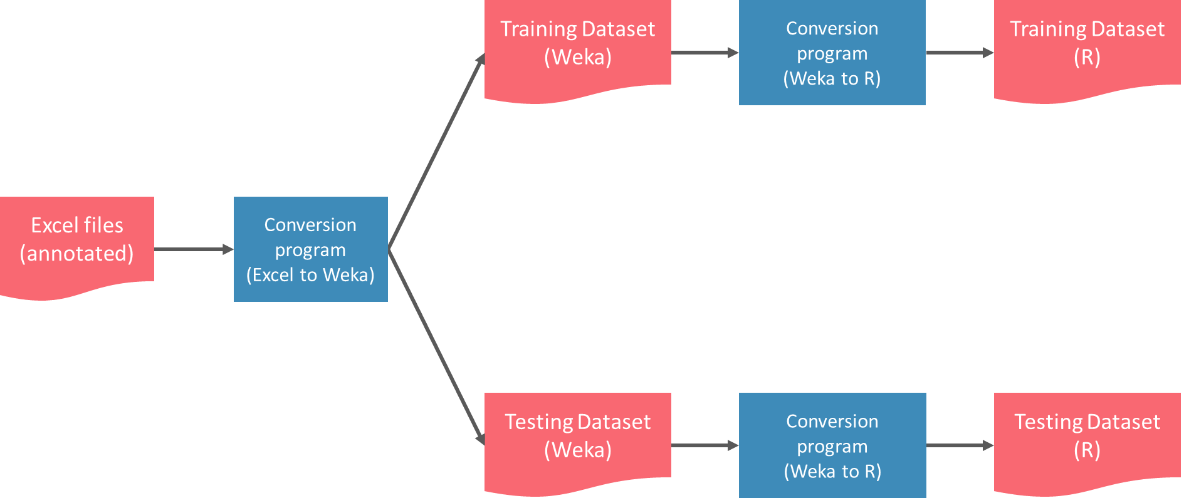
Figure 3.23 Diagram of Excel to Dataset Conversion.

The conversion program consists of several main functions, which are as follows:
- Information extraction from annotated Excel file
This function takes an annotated Excel file as input. There are a total of 20 documents generated for the system. The training dataset comprises of 2 datasets per personality trait: one for high trait, and the other one for low trait, which makes a total of 10 documents for the training dataset. The testing dataset is also divided in the same way, resulting in another 10 documents. The dataset division can be seen in Figure 3.24.

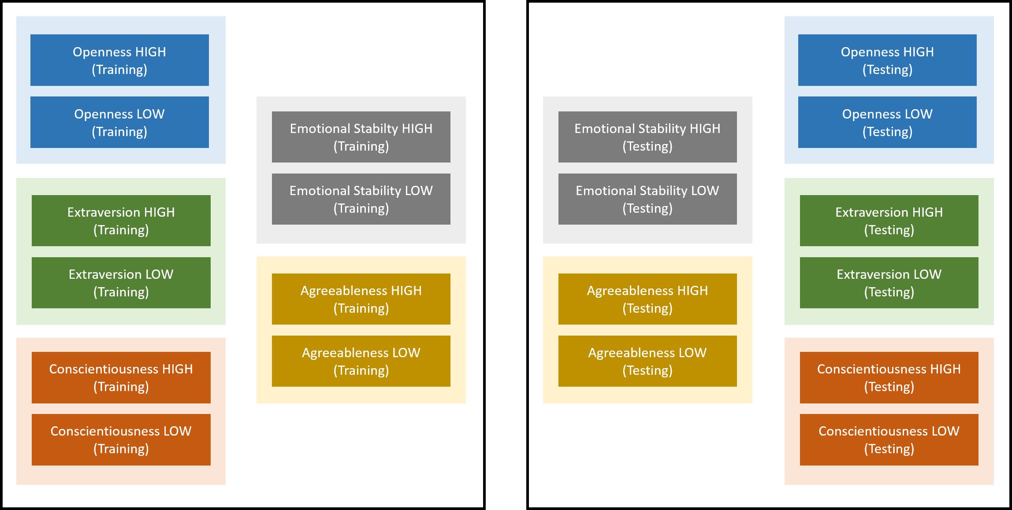
Figure 3.24 Division of Datasets

The file is scanned for 2 different information: the user’s Twitter behavior and the user’s tweets. This results in 2 outputs, namely a list of the user’s Twitter behavior and a list of the user’s tweets. Example of user’s Twitter behavior as output was shown in Figure 3.25. Figure 3.26 shows an example of user’s tweet list. The chosen behavior features are presented in Section 3.1.

Figure 3.25 User’s Twitter Behavior

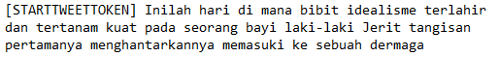
Figure 3.26 User’s Tweets List

- Tokenization
The main task of the tokenization function is to separate each tweet into a set of tokens. The list of tweets from the previous function are separated into n-grams with n=2. All alphabet occurrences in each term are replaced with their lowercase counterparts to ensure that the exact same words are considered the same term.
The list of tweets from the previous function are separated into n-grams with n = 2. Duplicates of extracted tokens are removed from the list. This function also counts the number of occurrences for each term.
Figure 3.27 shows the example of term after tokenization that counts the number of occurrences for each term.

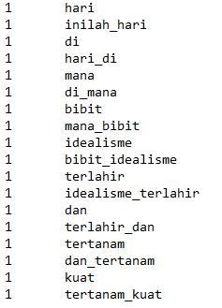
Figure 3.27 Example of Term After Tokenization

- N-gram normalization
The terms obtained from the previous function are normalized to resolve the noisy language of social media. There are 6 approaches implemented into the program to deal with existing abnormal terms.

- ConvertNumber
The ConvertNumber function is used to replace the occurrence of number(s) to proper letters. This function was adapted from Naradhipa & Purwarianti (2011)’s study with modification. The conversion rule for number “2” requires lemmatization to exclude prefix when copying character/string before “2”. The number to letter conversion rules are presented in Table 3.1. while a list of conversion examples are shown in Table 3.2.

Table 3.1 Convert Number Conversion Rules
Number | Conversion
0 | o
1 | i
2 | Copy character/string before “2”
3 | e
4 | a
5 | s
6 | g
7 | t
8 | b
9 | g

Table 3.2 ConvertNumber Conversion Examples
Abnormal term | Normal term
S4ya | Saya
bermain2 | bermain-main
sama2 | sama-sama

- FixSpelling
The FixSpelling function is used to fix abnormal terms which are slightly modified to imitate spelling of Indonesian words similar to that of the Indonesian old language. This function was adapted from Buntoro, Adji, & Purnamasari (2014)‘s study. The FixSpelling rules are presented in Table 3.3. Table 3.4 shows examples of FixSpelling conversion.

Table 3.3 FixSpelling Conversion Rules
Abnormal Form | Normal Form
oe | u
dj | j

Table 3.4 FixSpelling Conversion Examples
Abnormal term | Normal term
hapoes | hapus
djakarta | jakarta

- FixSuffix
The FixSuffix function is used to resolve occurrences of abnormal suffixes. This conversion rule was adapted from Buntoro, Adji, & Purnamasari (2014)’s study. The conversion rules for the FixSuffix function are given in Table 3.5. Table 3.6 shows examples of the suffix conversion rule.

Table 3.5 FixSuffix Conversion Rules
Abnormal Form | Normal Form
-ny | -nya
-nk | -ng
-x | -nya
-z | -s
-dh | -t

Table 3.6 FixSuffix Conversion Examples
Abnormal term | Normal term
donk | dong
sesungguhny | sesungguhnya
bersamax | bersamanya

- RemoveRepeat
Abnormal terms which have repeated letters are handled by the RemoveRepeat function. This normalization rule was adapted from Naradhipa & Purwarianti (2011). Table 3.7 presents conversion examples of the RemoveRepeat rule.

Table 3.7 RemoveRepeat Conversion Examples
Abnormal term | Normal term
looooh | loh
tidaaak | tidak

- CheckAlayDictionary
CheckAlayDictionary is a conversion rule which replaces abnormal words to their normal form based on a list of words stored in Kamus Alay (Alay Dictionary). This dictionary is generated from Naradhipa & Purwarianti (2011) to produce the same conversion rule. Alay Dictionary is a dictionary which consists of a list of abnormal terms which are mapped to their normal forms. This conversion rule checks for occurrence of an abnormal term which is listed on the Alay Dictionary, and attempts to normalize it by replacing it with the normal form. A complete list of AlayDictionary can be found in Appendix 4.
Table 3.8 shows examples of the CheckAlayDictionary conversion sample.

Table 3.8 CheckAlayDictionary Conversion Examples
Abnormal term | Normal term
br | baru
tggu | tunggu

- CheckKBBI
Unlike the functions above, CheckKBBI is not a conversion rule, but a countermeasure function which ensures that normal terms are left as it is and don’t need further normalization. KBBI is an abbreviation for Kamus Besar Bahasa Indonesia, which is an official dictionary of Bahasa Indonesia produced by the Language Center of the Indonesian Department of Education. If the checked term exists in KBBI, then the term is normalized and is not processed any further.
The complete order of the normalization is presented in Figure 3.28.

As shown in Figure 3.28, functions ConvertNumber, FixSpelling, FixSuffix, and RemoveRepeat are followed by functions CheckKBBI and CheckAlayDictionary as these are the only 2 functions which ensures that the terms are normalized.

- Generate LDA features
The tweets extracted are scanned for words that are listed on a topic produced by the LDA algorithm. Each topic occurrence was counted. This generates a list of 100 counts, where each count represents 1 LDA topic.
- Combine N-gram and LDA features
N-gram features and LDA features are combined into a single structure to be converted into a dataset.
- Omission of stop words
The most commonly used words in Bahasa Indonesia, referred to as stop words, are omitted from the list of n-gram features. The list of stop words is taken from Tala (2003)’s study on Bahasa Indonesia information retrieval.
- Training and testing dataset creation
After a series of normalization methods, the terms for each level (high or low) of personality trait are accumulated into 1 dataset per personality trait. These accumulated terms are the n-gram features for the system.
The total number of the final dataset is 20. There are 10 datasets in arff format and another 10 in csv format, which are utilized by Weka’s Support Vector Machine algorithm and XGBoost’s Gradient Boosting Tree algorithm via R respectively.
Figures 3.29 to 3.31 shows an example of the dataset in arff format, while Figure 3.32 shows an example of the dataset in csv format.
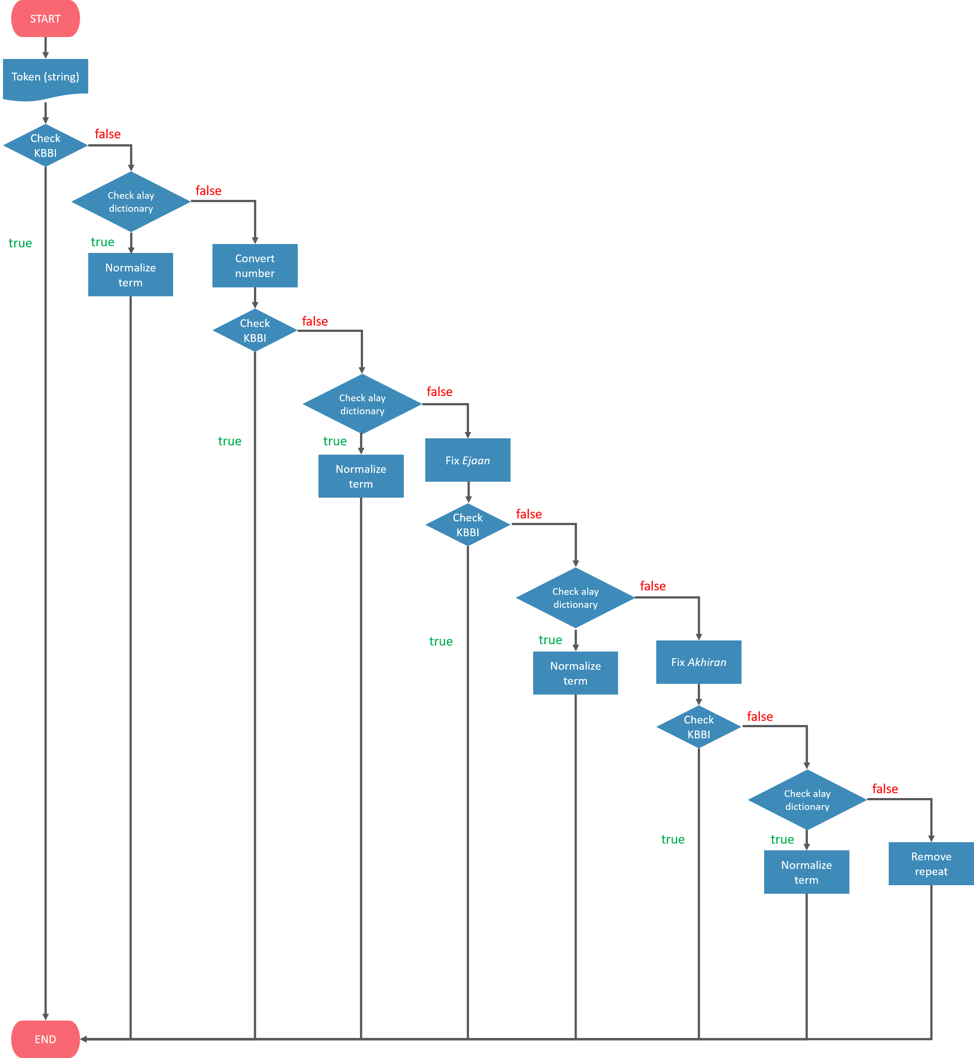
Figure 3.28 Flowchart for Term Normalization

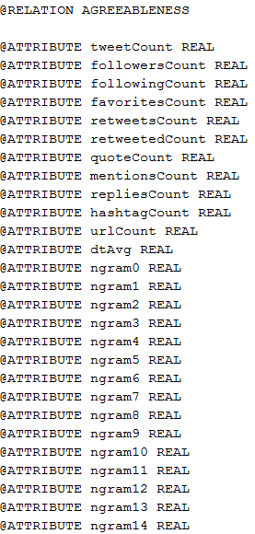 | 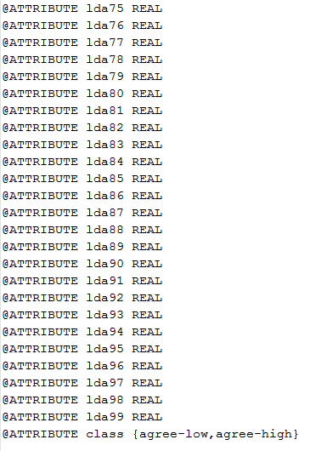
Figure 3.29 Example of Relation and Attributes of arff Dataset

Figure 3.29 is an excerpt from the dataset showing the name of the dataset relation, attributes, and classes. The relation acts as the name of the dataset. Attributes are a list of features utilized in the dataset. In this dataset’s case, the features cover user behavior (e.g. tweetCount, followersCount, followingCount, favoritesCount, etc.), n-gram features (e.g. ngram0, ngram1, ngram2, ngram3, etc.), and LDA features (e.g. lda0, lda1, lda2, lda3, etc.). The class indicates the possible predictions that the dataset can make (e.g. agree-low and agree-high).

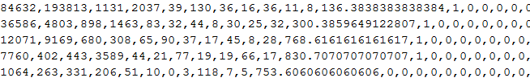
Figure 3.30 Example of Attribute Values for 5 instances of arff Dataset

Figure 3.30 is an excerpt from the second part of the dataset, which are the values for each attribute. Each row represents 1 instance, and each column (separated by commas) represents 1 feature. As an example, in Figure 3.30, the value of the first feature of the first instance (column 1, row 1) is 84632. Therefore, the first instance’s tweetCount feature is 84632.

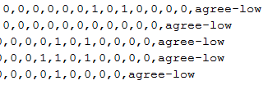
Figure 3.31 Example of Classes for 5 instances of arff Dataset

Figure 3.31 is the backmost column from Figure 3.30. The last column indicates the class of the instance.

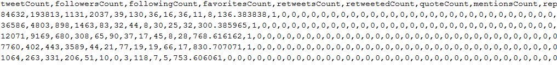
Figure 3.32 Attribute and Attribute Values for 5 instances of csv Dataset

Figure 3.32 is an excerpt of the csv dataset. The first row lists the attributes of the dataset, while the second row onwards lists the attribute values for each instance.
Each algorithm’s dataset comprises of 5 datasets for training and 5 datasets for testing, where each personality trait is represented as 1 dataset.
The final dataset distribution is shown in Figure 3.33.
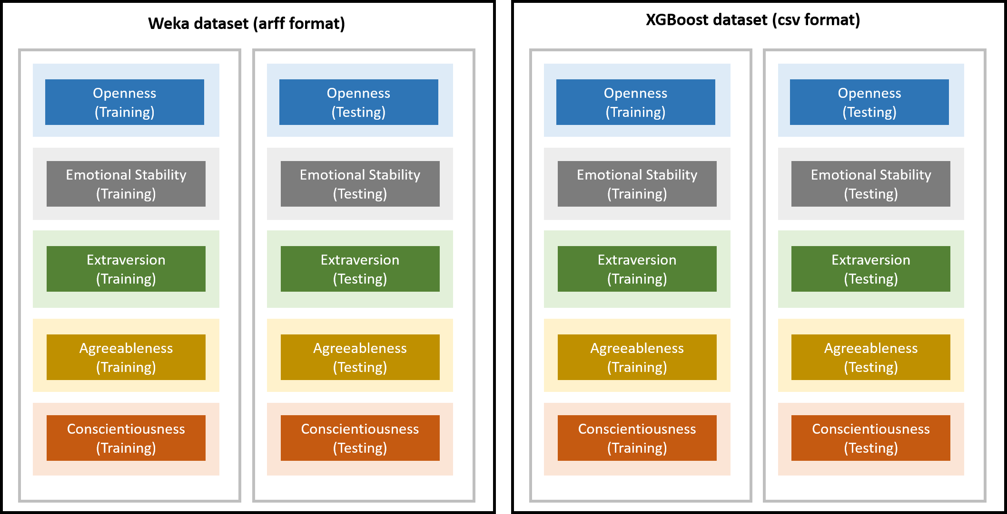
Figure 3.33 Distribution of Final Dataset

Build Prediction Model
Various selected features were crossed with each other to see which prediction model performs the best. A set of training and testing dataset are generated for each set of features. The datasets are then trained using Support Vector Machine and Gradient Boosting Tree, and evaluated afterwards.

Train Prediction System
A total of 5 classifiers are created for the personality prediction, where 1 classifier provides prediction for 1 personality trait. The final training datasets for each algorithm from Section 3.2 were loaded into their respective classifiers.

Evaluate Prediction System
After training the model, evaluation is done to measure how well each classifier does and the performance for all classifiers in general. Evaluation is done in 2 ways. The first method involves using k-fold cross-validation, while the second method loads the final testing dataset into the system. Evaluation measures were calculated with Accuracy.

Implement Prediction System to Application

Create UI Mockup
A mockup design of the Android application’s user interface was created. The user interface created in this study divides the application into several screens, namely the Prediction screen, Result screen, Information screen, Trait Information screen, and Contact Information screen. An additional screen called Navigation Drawer screen is also provided in the application.
- Prediction screen

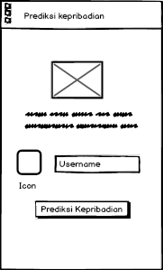
Figure 3.34 Mockup of Prediction Screen

Figure 3.34 is the first screen that is shown upon executing the application. This screen consists of a text field which allows the user to input the username to be evaluated for his/her personality trait level.

- Result screen

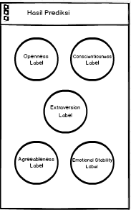
Figure 3.35 Mockup of Result Screen

The result screen shown on Figure 3.35 consists of 5 main portions, listing the user’s level of each personality trait. These portions are clickable which allows the user to view more detailed information regarding the trait.

- Result Trait Information

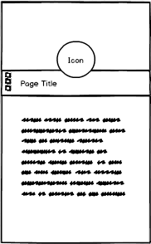
Figure 3.36 Mockup of Result Trait Information Screen

The result trait information screen on Figure 3.36 is the screen that appears upon clicking one of the personality traits in the result screen or the information screen. The screen contains the description of the requested personality trait.

- Information screen

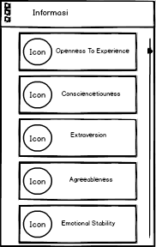
Figure 3.37 Mockup of Information Screen

The information screen’s appearance on Figure 3.37 is similar to the result screen, but without high-low labels from each personality. This is because the information screen’s purpose is only to show information regarding each trait.

- Trait information screen

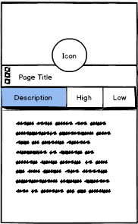
Figure 3.38 Mockup of Trait Information Screen

The trait information screen shown in Figure 3.38 is the screen that appears upon clicking one of the personality traits in the result screen or the information screen. The screen contains the description of the requested personality trait.

- Contact information screen
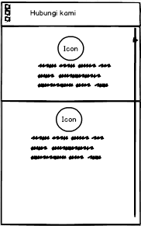
Figure 3.39 Mockup of Contact Information Screen

Figure 3.39 shows the contact information screen. The contact information screen’s purpose is to show information regarding the developer which the user can contact for inquiries.

Implement UI Mockup to Android
In this step, the mockups designed for Android are implemented to create the application. Creation of application was done in Android Studio.

Implement Prediction System
Implementing the prediction system into an Android application would result in heavy usage of the phone. It is the main motivation for implementing the prediction system to a server.
Another program must be created to be executed in the server upon receiving a request from a client.

Quality Assurance Measures
Quality measures were taken to ensure that the program is working properly (i.e. flow of data from one function to another, interaction between screens/activities).
Flow of data was checked by generating a text file upon executing each function in the program. The text file was then thoroughly checked to see whether the data is processed correctly and whether data is passed correctly from one function to another.
Interaction between screens/activities were checked by testing whether each activity is able to navigate to its intended activity/activities.

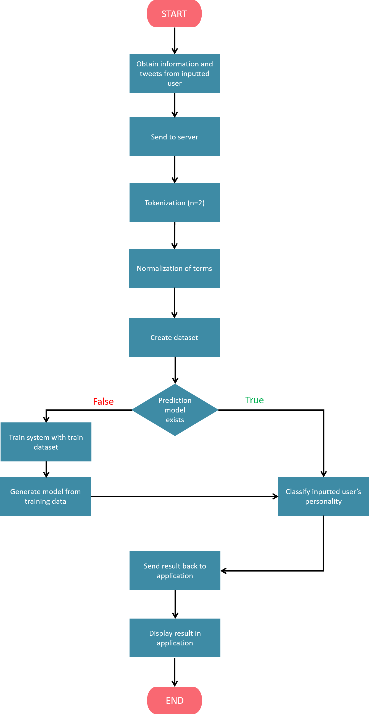
Figure 3.40 Program Flowchart

Program Flowchart
Figure 3.40 shows the flowchart on how the Android application and server are integrated to build a personality prediction system.
In the Android application, the program starts by obtaining user information and user tweets of the inputted username. Once the information has been retrieved, the Android application sends the information and tweets to the server. The list of tweets is then tokenized into bigrams. Afterwards, each term goes through a series of checks and normalization functions to minimize the occurrence of slang words. Once the terms have been normalized, the system converts the data into the dataset format supported by the classifier. This acts as a testing dataset. If the system has conducted a prediction before, a prediction model would have already existed, so that no re-training is required by the system. On the other hand, if it is the system’s initial prediction, it will need to train from the training dataset in order to generate a prediction model. Once the prediction model is loaded, the system performs the classification based on the previously generated testing dataset. Once classification is complete, the results are sent back into the Android application and displayed in the application’s user interface.

https://dumps.wikimedia.org/idwiki/latest/

